Overall Performance

## Performance Chart:

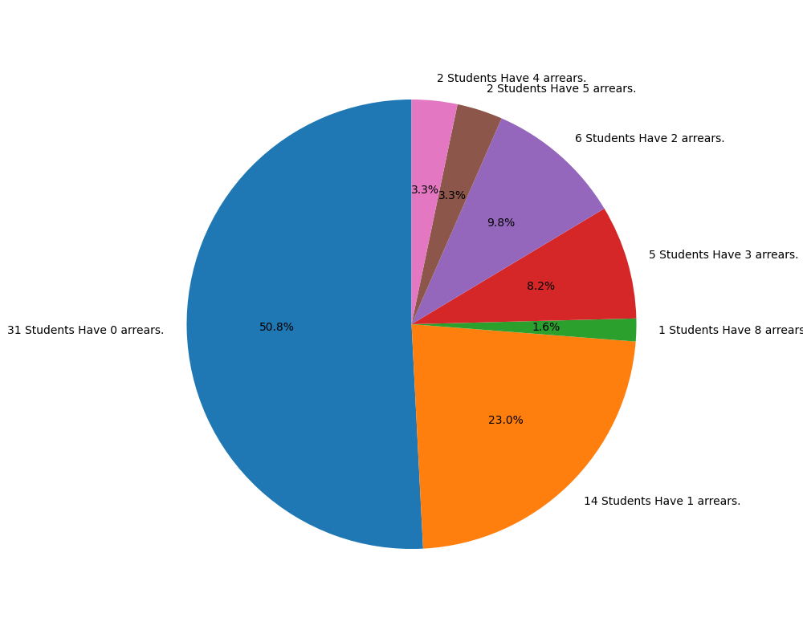

## Performance Summary:

### Student Have 8 arrears:

ANTONY DANIEL M F

### Student Have 5 arrears:

NARESH L  
SAKTHISRI K.S

### Student Have 4 arrears:

PRANAV KUMAR M  
SANTHOSH K

### Student Have 3 arrears:

ARULMURUGAN V  
LALIT S  
MOHAMMED ASHIQ S  
SABARIGIRI S  
SARATHI S

### Student Have 2 arrears:

DHARSANAA A  
GOKUL C  
HARSHAVARTHAN H  
JAMES NITHIL V  
MUKILAN S  
PHILIPS KUMAR R

### Student Have 1 arrears:

ABIRAMI D  
AKILRAJ S  
DIVYAPRAKASH K  
GOWTHAM B  
MOHAN RAJ S  
MONA C  
MONISHA V  
RANJITH B S  
RAVINDRA RATHICK S  
REBHIN JEEVARAJ G  
SABARIHARIHAREN G  
SARAVANAN A  
SILAMBARASAN S  
SURYA B

### Student Have 0 arrears:

AARTHI L  
AKSHAYA N  
BOOBALAMURUGAN S  
CHANDRU N  
CHANDRU T  
CHANDRU T  
DHANUSH RAJ O  
DHARSHINI R  
DHATCHANAMOORTHI S  
DHIINESH M  
GOPIKA R  
HARIHARASUDHAN S  
HARIPRASATH S  
HEMACHANDRAN A  
JERUN F  
KARTHIK CHINNADURAI  
KEERTHANA M  
MAHESH M  
METHUNRAJ H  
NANDHABOOSSAN K  
NAVEEN B  
PAVEENKUMAR A  
PRASANNA S  
SABARIGIRIVASAN S  
SAISANTHOSI S  
SOPNA V  
SUBHASRI V  
VENKATESH S R  
VIDHUMITHAA G  
VIDHYA B  
VIJAYKUMAR S